**Lab 14: Data Encoding**

**Course Name:** Malware Analysis and Reverse Engineering (IAM302)

**Student Name:** Nguyễn Trần Vinh – SE160258

**Instructor Name:** Mai Hoàng Đỉnh

**Lab Due Date:** 29/2/2023

**Purpose**

You will practice the techniques in chapter 13

**What you need:**

* A Windows machine with the tools we have been using installed.

**Beacons**

* The book recommends running the malware with another VM simulating the Internet with inetsim, but I don't see any good reason to bother with that. I just connected a VM to the real Internet and ran the malware.

**Launch the Lab13-01.exe file**

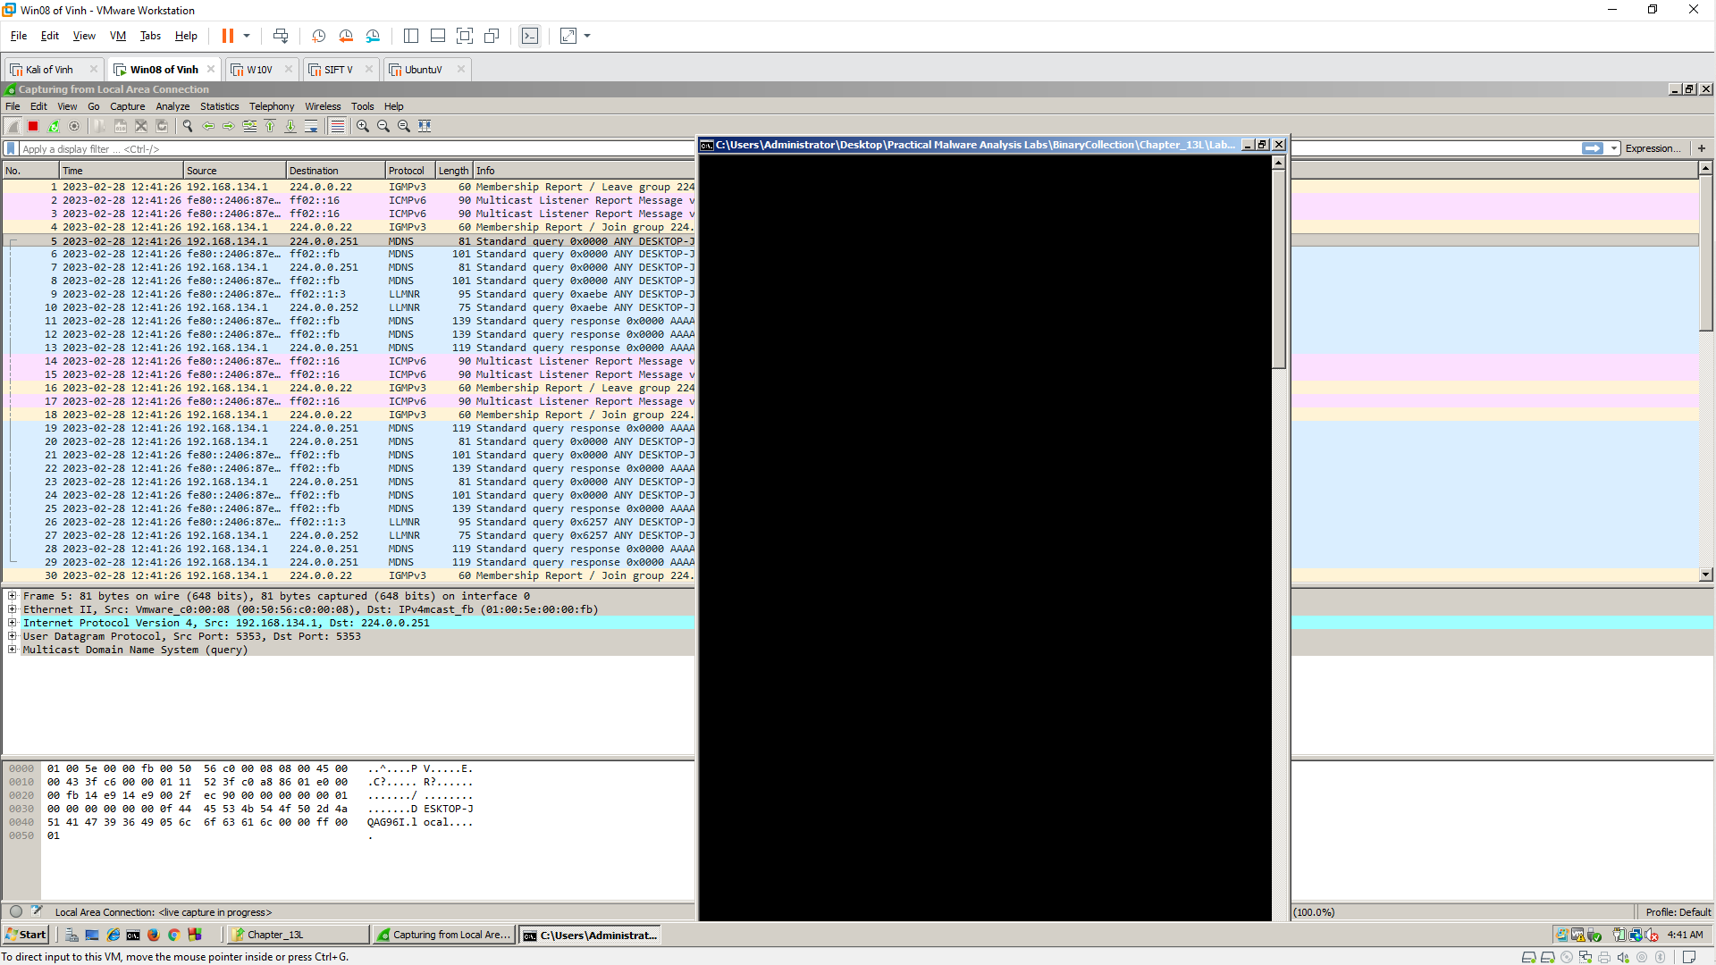

**Wireshark**

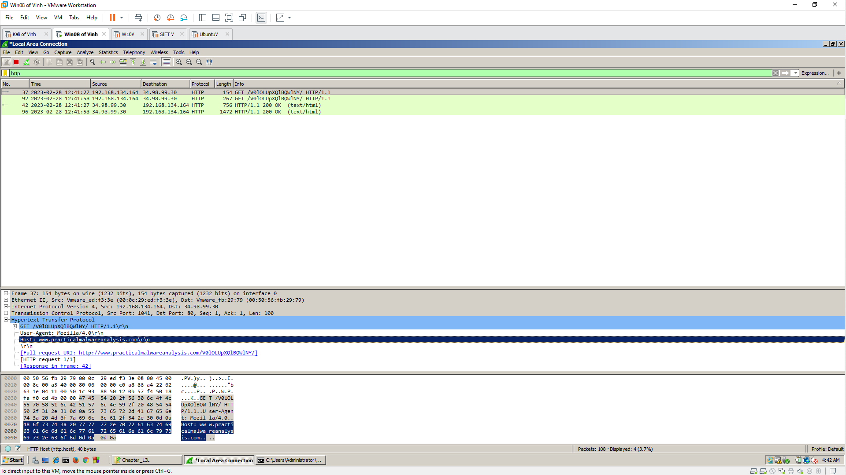

**Strings**

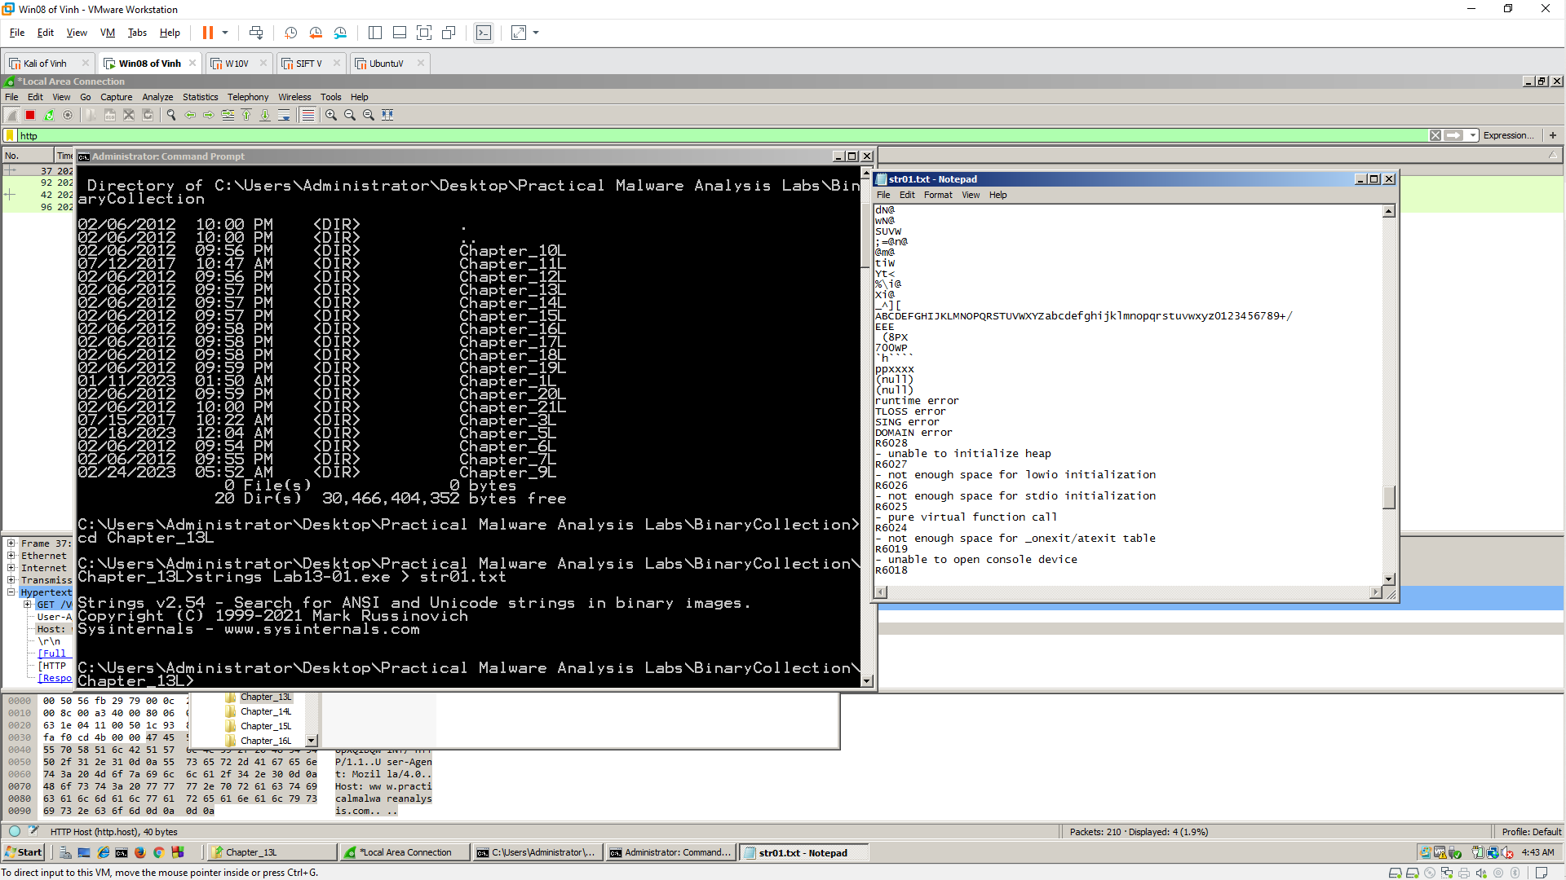

**IDA Pro**

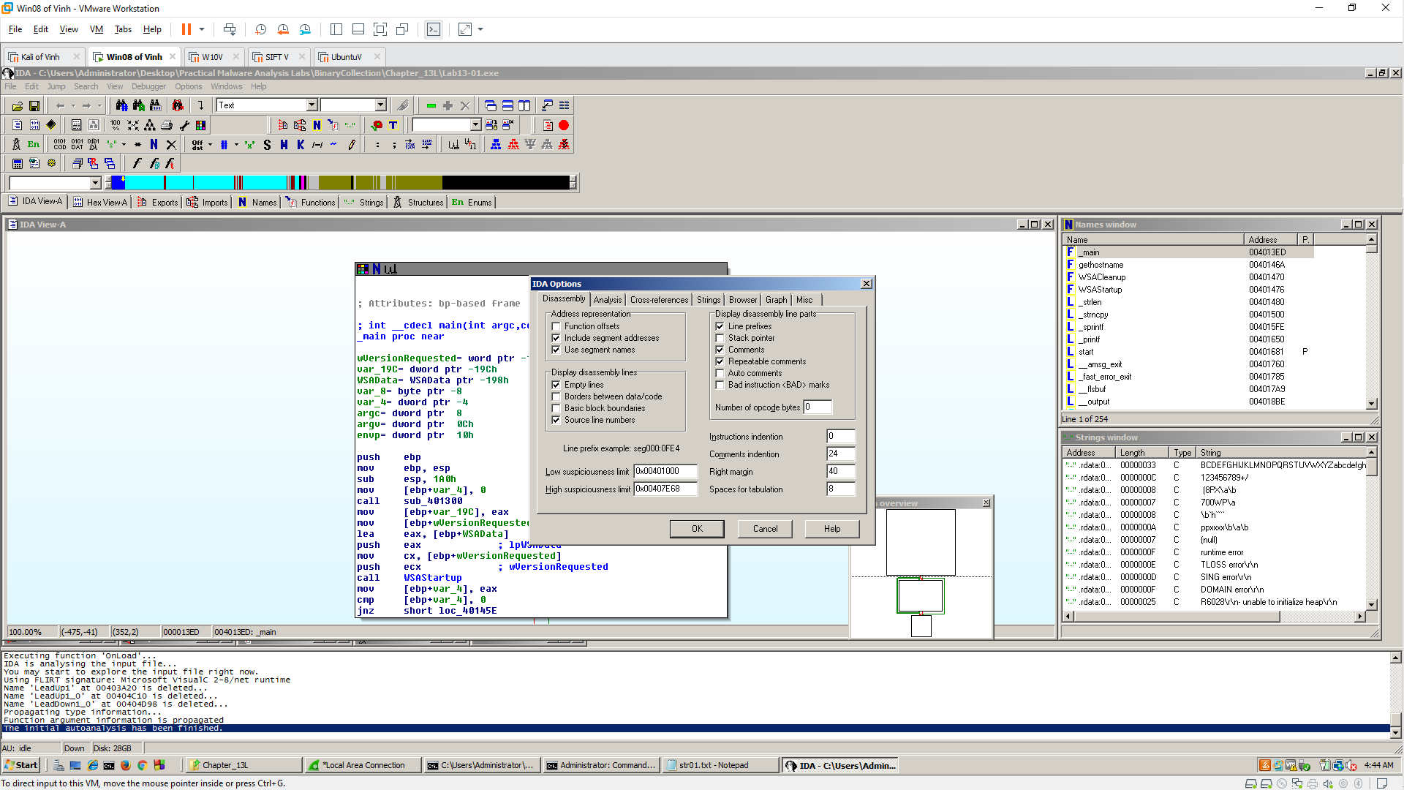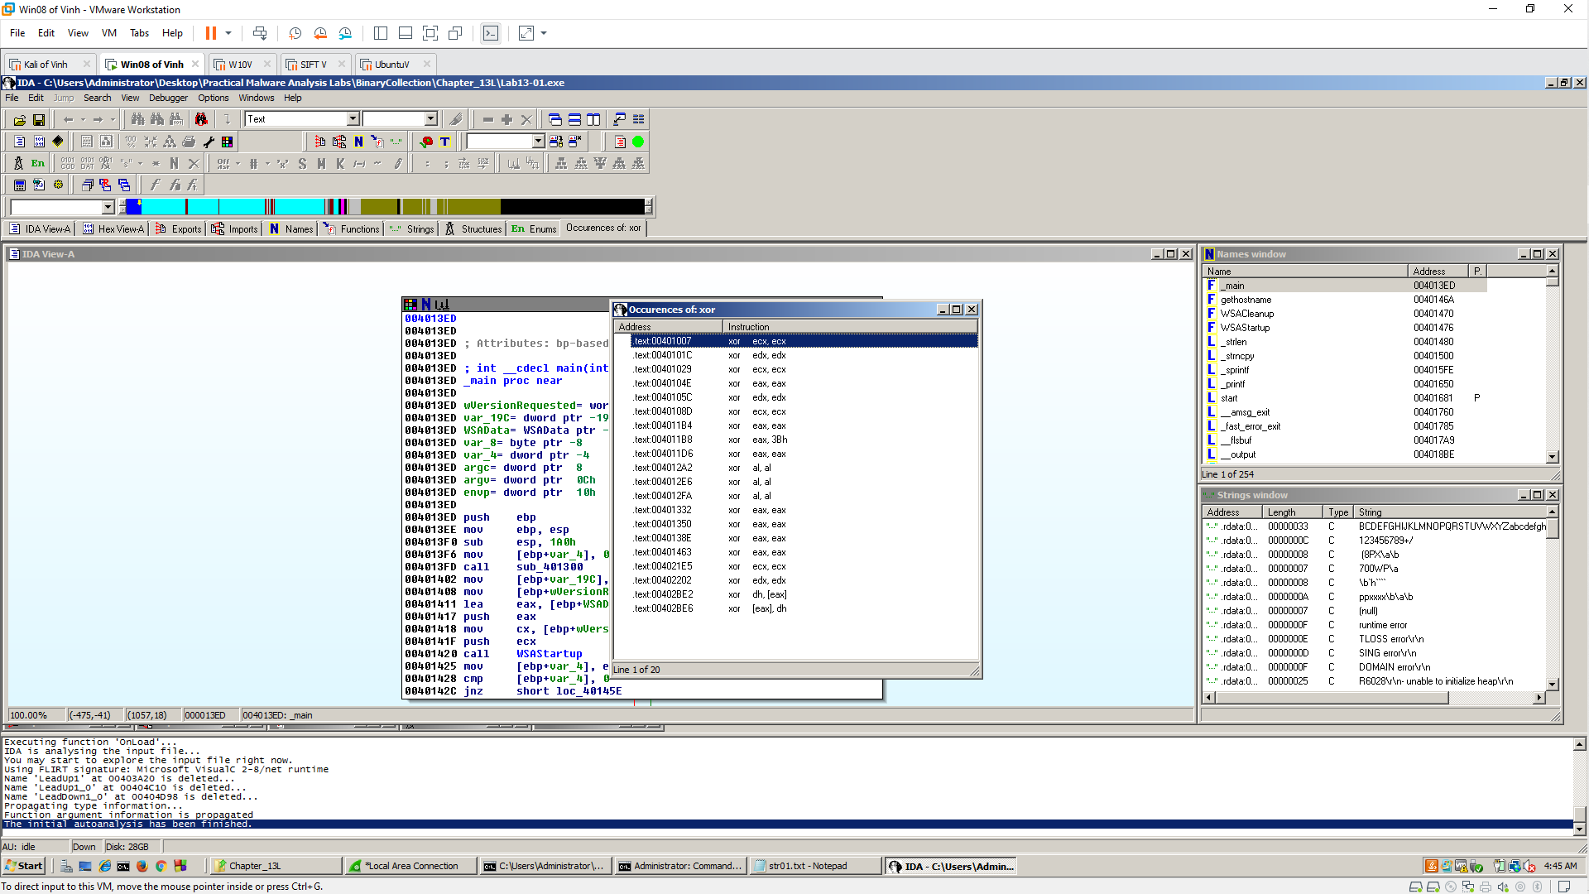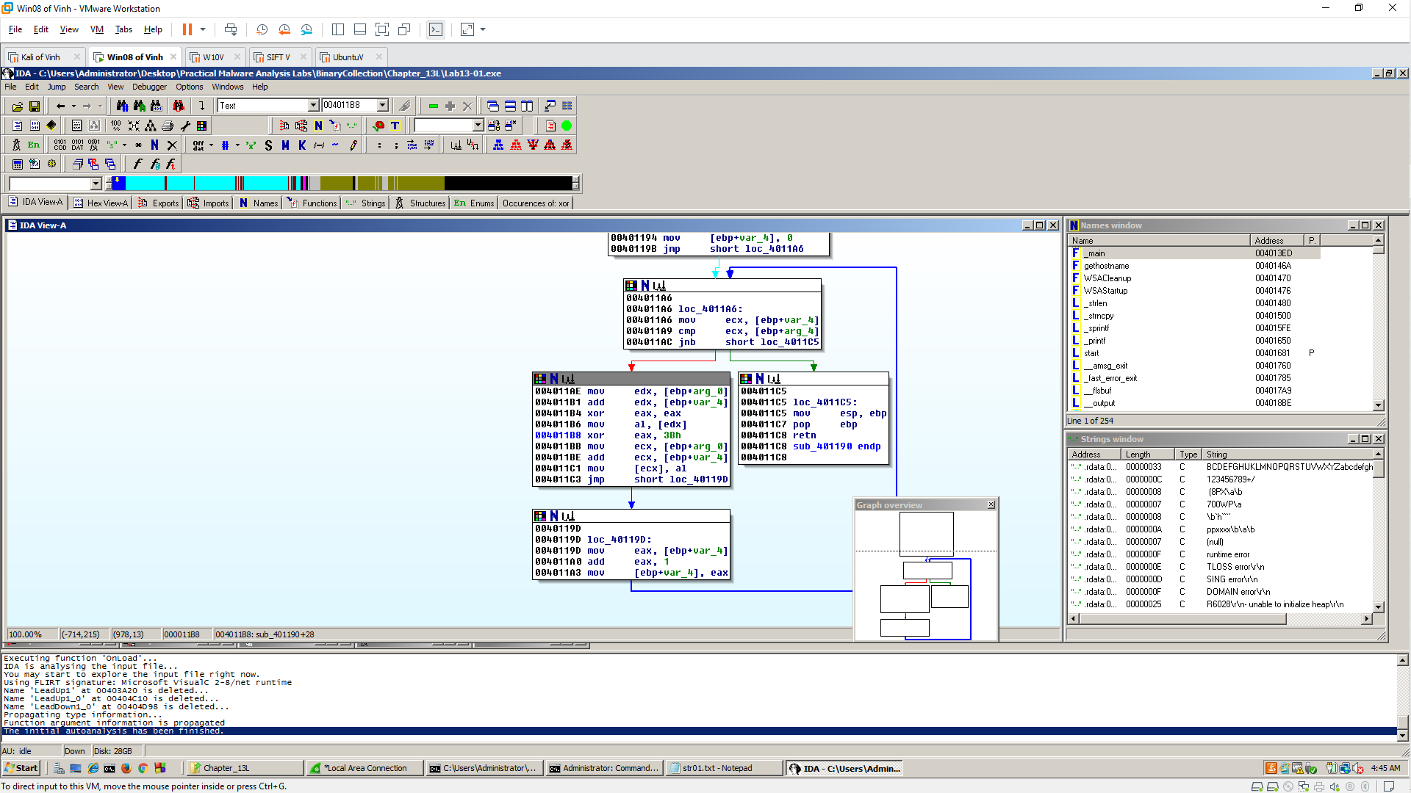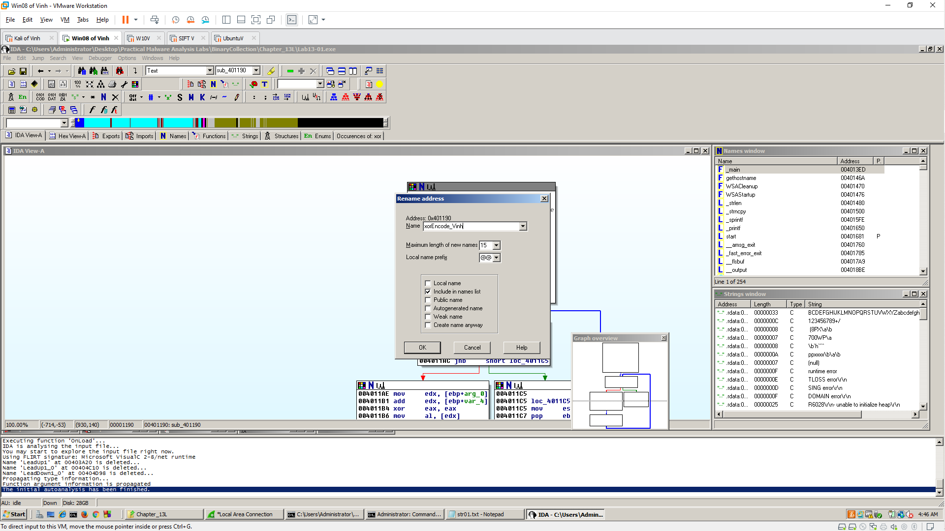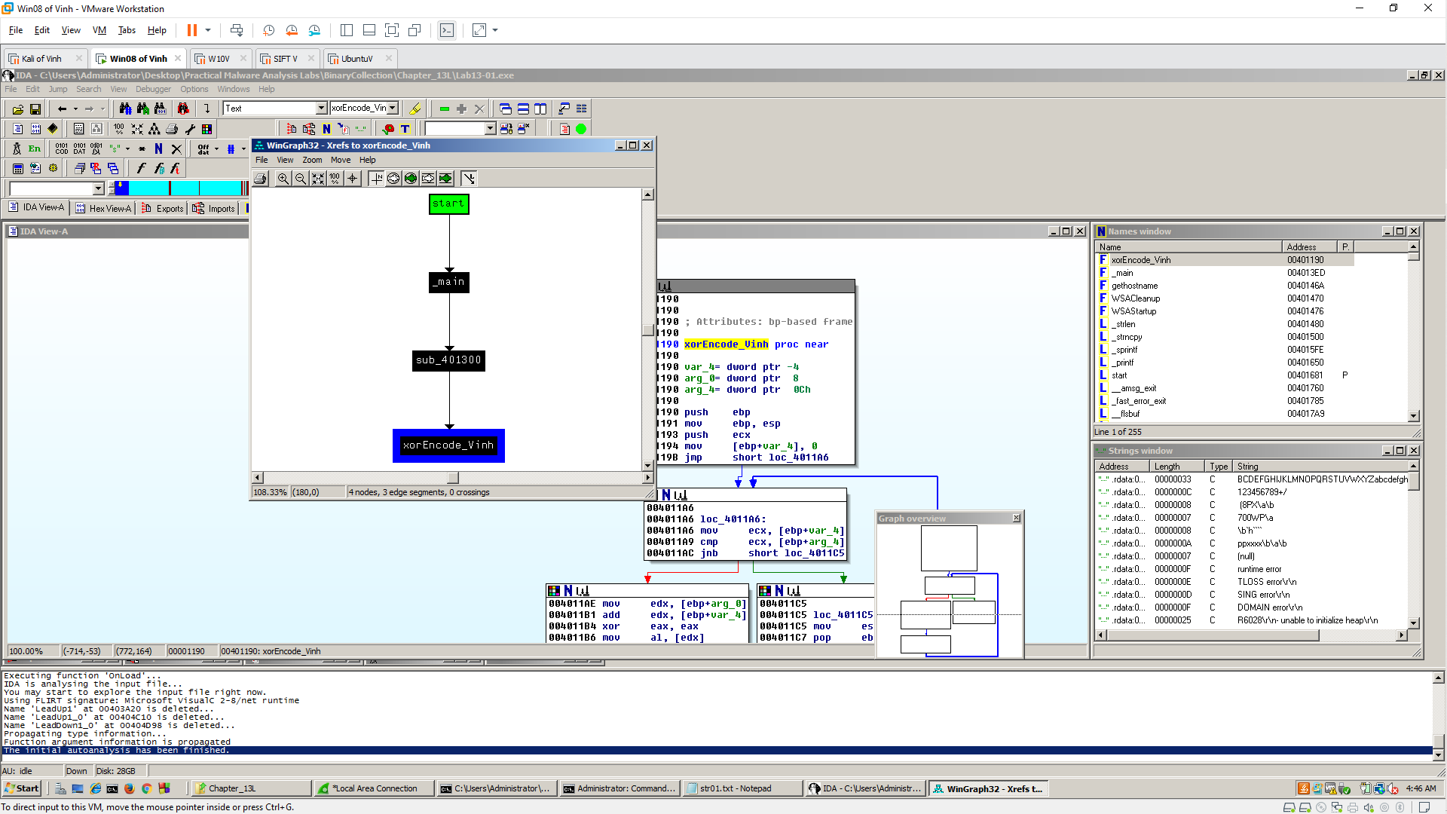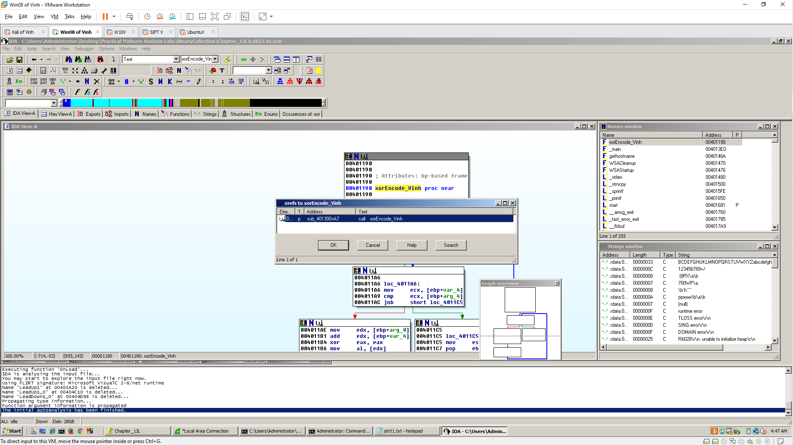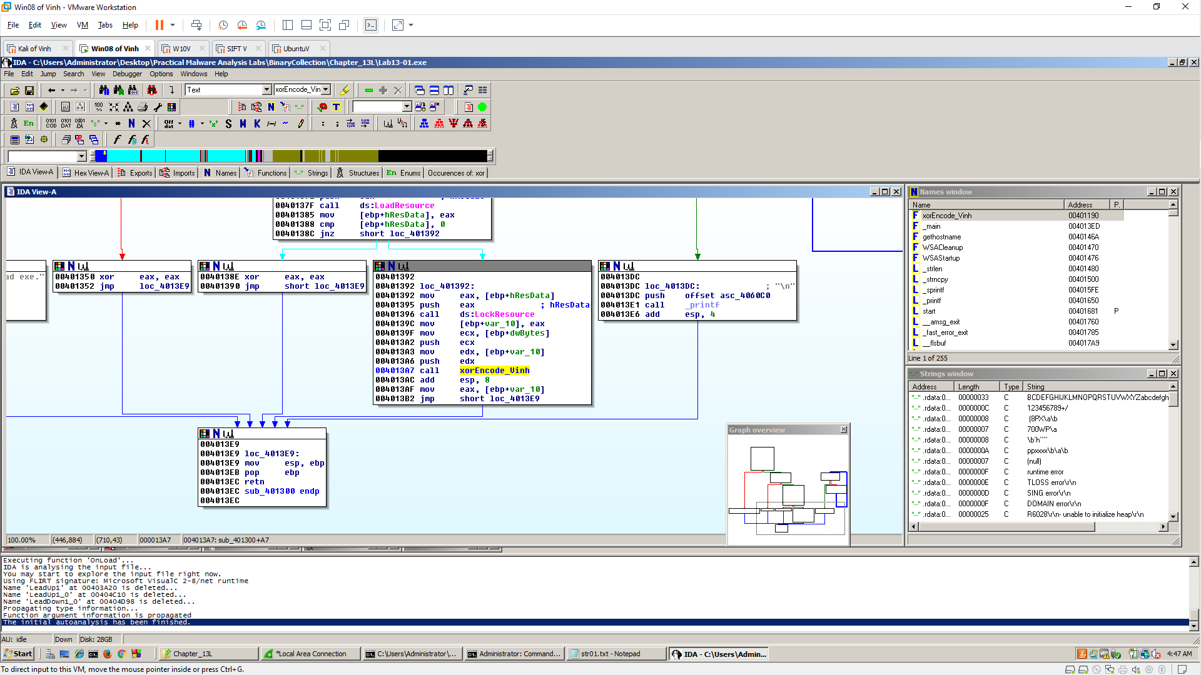

**PEview**

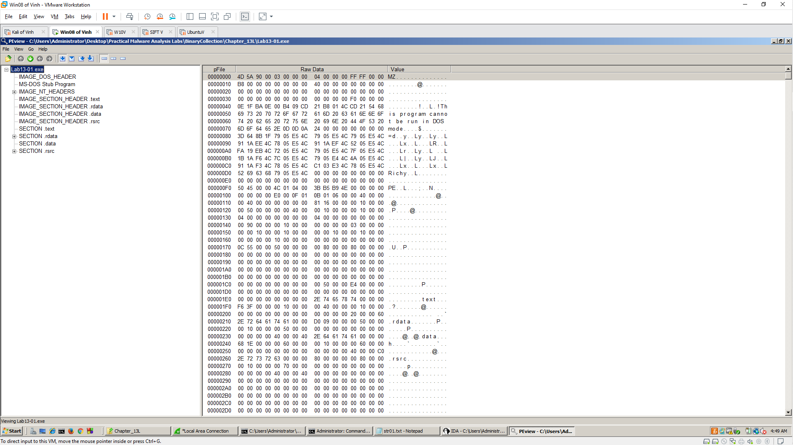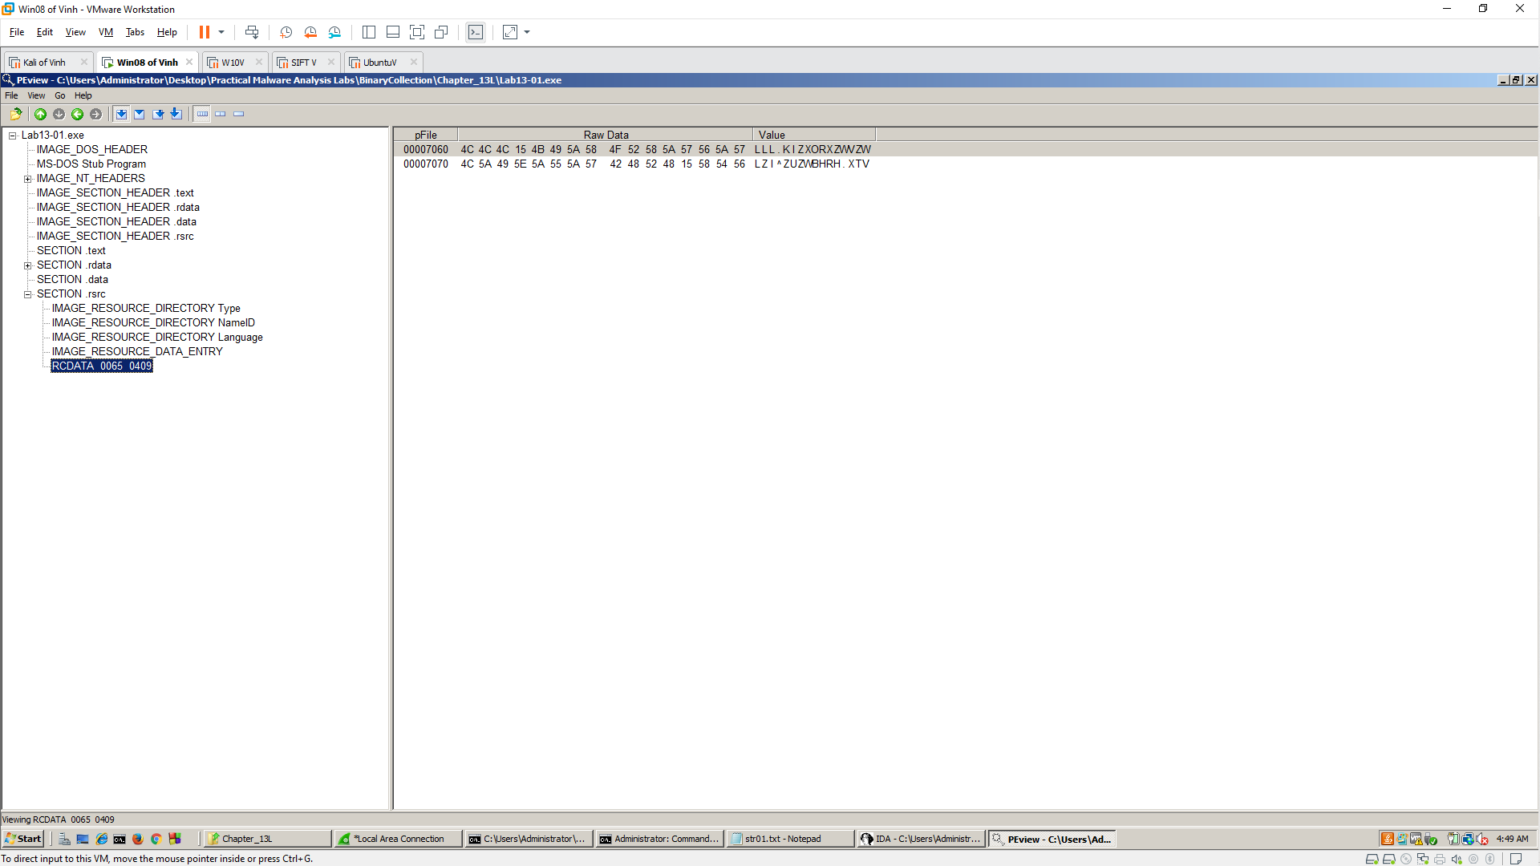

**WinHex**

